### **Events Overview**

Add and Manage Events



Written By Scott Smith

Created 3 years ago

The system provides the ability to view & manage all the Events in this Events Overview page. You have the ability to Create/Manage Events for the Students.

**Navigation:** Click on the Events menu and Events sub-menu to navigate to the Events Overview page.

**Security:** All the created Events are displayed on this page. The Business Account users will see the list of all the Franchises/Centers in the dropdown list to filter the Events based on the Franchise/Center. Franchise/Center specific users will see only their Events on the page. Parents & Students will be able to view the events but can’t perform any actions.

Clicking on the “Create Event” button will open a popup to create the Event.

In the popup, you have the ability to specify the following information -

**Note:** All the fields displayed here are customizable including the ability to set Permissions (like who can view or edit the content). The customizations can be done in “Admin > System Config > Form Templates > Event”

**Event Name -** Specify the name of the Event.

**Event Status -** Specify the status of the Event (Active or In-Active). By default, the Active option is selected.

**Category -** Specify the category of the Event. In the dropdown list, you have the ability to select the Event Type & Category. Refer to the below diagram which explains the flexibility and the hierarchy to create & manage the Events -

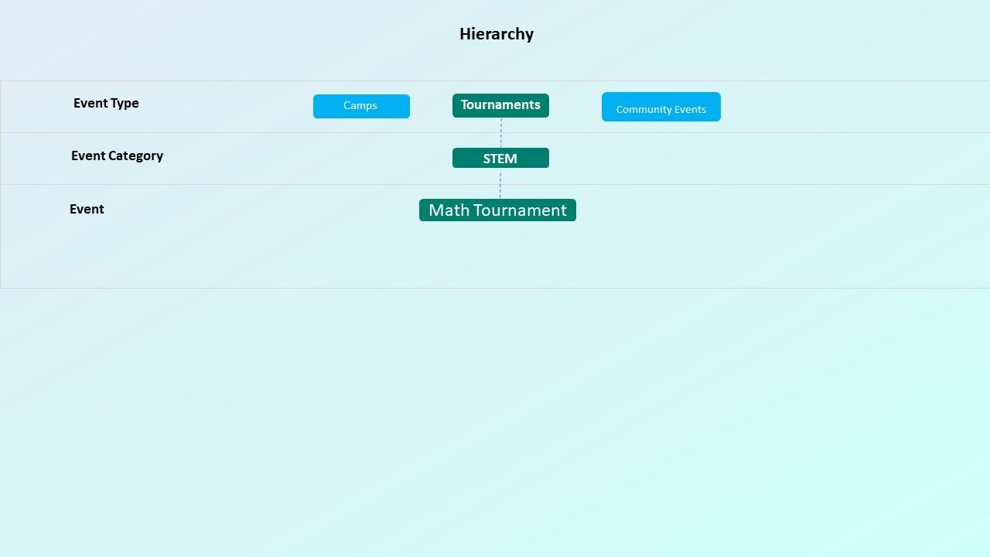

You can create the Types and Categories in “Events > Types Setup” and “Events > Categories Setup”.

**Staff -** Select the Staff that is the owner of this Event.

**Event Image -** By default, an image is selected but you have the ability to change the image by hovering on it and clicking on the upload icon.

**Details >**

**Online/In-Person Training -** Specify if this Event will be conducted as an Online Event or In-Person Event. This is an optional field.

**Location -** Specify the location where the Event will be. This is an optional field.

**Age From -** Specify the limit from which Age the Student is eligible to attend the Event. This is an optional field.

**Age To -** Specify the limit until which Age the Student is eligible to attend the class. This is an optional field.

**Accepted Gender -** Specify which Gender can attend the Event.

**Manage Timings -** The “Manage Timings” button will not be enabled until you create the Event. Create the Event and click on the “Manage Timings” button. In the popup, the following information is available -

1. **Display in Website -** checkbox provides the ability to display the Event on the website (via the URL or through embedded script). If unchecked then the Event will not display.
2. **Slots -** Specify the number of Slots available for the Event. This is an optional field.
3. **Start Date -** Specify the Start Date from when the event starts.
4. **End Date -** Specify the End Date when the Event ends.
5. **Start Time -** Specify the End Time from when the event starts.
6. **End Time -** Specify the End Time when the Event ends.
7. **Manage Pricing -** The button will not be enabled until you save the Event timing. Once the button is enabled and clicked then a popup opens. In the popup, the following information is displayed -
   1. **Price -** Specify the Price of the Event
   2. **Billing Cycle -** Specify the Billing Cycle when the Payment should be deducted on a recurring cycle.
   3. **Auto Deduct -** If the Auto Deduct is specified as Yes then the Payment will be deducted automatically. If it is set to Manual then the Payment is not deducted automatically even if the Billing Cycle is set. Refer to the Notes about some additional details.
   4. **Recurring Start Date -** Specify the Date from when the Recurring should start. Note that the individual recurring start date will take priority over the Event recurring start date.
   5. **Recurring End Date -** Specify the Date when the Recurring should end. Note that the individual recurring end date will take priority over the Event recurring end date.
   6. **Coupon Code -** Select the Coupon code if you want to set any discount at the Event level. You can add or manage coupons by clicking on the “Manage” button.

**Manage Coupon >**

* + 1. In the popup, all the coupons created for the Business or the Franchises are displayed (depending on the account the user is logged in). For Business account users, the “Copy Item(s) to Franchises” button is displayed along with Sync settings. This allows adding the coupons to the Franchises that they can use. For Franchise/Center account users, these buttons are not displayed but can add their own coupons.
    2. You can also manage all the coupons in Admin > System Config > Manage Coupons page.

**Add New Coupon >** Clicking on the “Add New” button will open a popup to add a new coupon with the below fields.

* + 1. **Coupon Code -** Specify the Coupon Code that will be used by the users to get a discount.
    2. **Coupon Discount Type -** Specify the Type of the Discount. The “Discount by Number” option provides the ability to provide the discount based on the number specified in the “Coupon Discount” field. The “Discount by Percentage” option provides the ability to provide the discount by Percentage specified in the “Coupon Discount” field. The “Fixed Amount” option provides the ability to fix the total amount irrespective of the total payment amount in the cart. Refer to the Notes in the popup when this option is selected for more details.
    3. **Coupon Discount -** Specify the Discount Number of Percentage to provide the discount.
    4. **Coupon Limit -** Specify the total number of coupons that can be used for the Event enrollments.
    5. **Coupon Start Date -** Specify the Date from which the Coupon should be applied.
    6. **Coupon End Date -** Specify the Date until when the Coupon should be applied.
    7. **Is General -** If this is checked then this Coupon is considered as General Coupon and can be used for any Event. If it is not checked then the coupon can be used only for the Events that it is selected.
    8. **Is Use for recurring -** If this is checked then the coupon will be applied for all the recurring payments. If it is not checked then it will be applied only for the first time payment.
  1. **Event Fee -** Specify the Event Fee which is different from the Price (Event Amount). This can be used for the Fee like Registration Fee, Material Fee, etc.
  2. **Fee Details -** Specify the details of the Fee so that it will be easy to know for which the fee is charged.
  3. **Recurring Event Fee -** If this is checked then the Fee will be applied for all the recurring payments. If it is not checked then it will be applied only for the first time payment.

1. **Event Template -** This field provides the ability to update the UI of the Event that will display on your website through a link or embedded script. Clicking on the button will open a popup to modify the UI elements of the Event.
2. **Total Registered -** This field displays the number of people registered (Active or In-Active) to the Event.
3. **Calendar Event Color -** This field provides the ability to define the color of the Event that will be displayed in the Event Calendars.
4. **Calendar Event Font color -** This field provides the ability to set the font color of the Event that will be displayed in the Event Calendars.
5. **Active Registrations -** This field displays the number of people registered to the Event and are Active.
6. **Calendar Event Border Color -** This field provides the ability to define the color of the Event border that will be displayed in the Event Calendars.

**Description -** Specify the high-level description of the Event in the rich text editor. This will be displayed in the Enrollments Page or embedded script that you can place on your website.

**Discussion -** This tab can be used to perform any internal discussion for maturing the process or content of the Event, any questions or comments about the Event, etc. All the users who have access to the page and the Event popup can discuss, reply to a comment, Like, edit or delete the comments.

**Attachments -** This tab can be used to attach and manage any documents for the Event. Clicking on “Add Attachments” will open a popover to add Attachment from different sources like Computer, Dropbox or Google Drive. If you select Google Drive, you will have 2 options. 1) You can add the Google Drive document link and 2) You can upload the document from Google Drive into the System. For the 1st option, any update made to the Google Drive document will reflect the changes here. If the link changes in Google Drive then you will no longer be able to access from here. For the 2nd option, any update made to the Google Drive document will not reflect the changes here because the file is uploaded to this system. Once the attachments are added, you have the ability to download, delete or view the documents. The Viewer provides the capability to view the documents without the need to download them. However, there might be some files that you can’t view.

The security of the attachments on who can add/view/download/delete can be managed in “Admin > System Config > Attachments Config”.

**Checklist -** This tab can be used to add any checklist items or tasks related to the Event. You have the ability to add/update/remove/reorder the items/tasks.

**History -** This tab provides the activity/history details of the Event information.

In the Events overview page, the grid displays the list of events that are created. When you hover on the row in the grid, the Actions button display to edit or delete the Event based on the permissions.

### **Event Types**

Add and Manage Event Types



Written By Scott Smith

Created 3 years ago

The system provides the ability to create Types for the Events to provide the flexibility to cover different scenarios.

Here is the Hierarchy of how you can set up Events for different Event Types -



Event Type is the top level in the hierarchy to differentiate the Events based on the Type of your Event offerings. Example - Tournaments, Camps, Community Events, Professionals, etc. You can also create Events without any type and all the Events would use 1 Enrollment form. The Event Types can be defined in Events > Events and Events Types Setup in the Business accounts. Franchises will not have the ability to define the Events Types and should coordinate with the Business admins to add or update Event Types.

In Events > Events > Manage Events page, you will see the hierarchy structure of your Types setup & the Categories for each Type and the Events for each Category. The page also provides the links to view the page or section on how it looks for the end-users for each Type. These links (1 per each Type) can be used on your website or clicking on the Embedded script button will provide you the embedded script for each type that can be used on your website to display the list of Events in a similar view.

### **Event Categories**

Add and Manage Event Categories



Written By Scott Smith

Created 3 years ago

The system provides the ability to create Categories for the Events to provide the flexibility to cover different scenarios.

Here is the Hierarchy of how you can set up the Events for different Event Categories -



Event Type is the top level in the hierarchy to differentiate the Events based on the Type of your Event offerings. Example - Tournaments , Camps, Community Events, Professionals, etc. You can also create Events without any type and all the Events would use 1 Enrollment form. The Event Types can be defined in Events > Events and Events Types Setup in the Business accounts. Franchises will not have the ability to define the Events Types and should coordinate with the Business admins to add or update Event Types.

Event Categories can be defined for each Event Type. Under each Event Type, you can differentiate your offerings with different Categories. Example - Under Tournament Event Type, you can define categories like STEM, Professional etc. You can also create Events without any Categories under an Event Type. The Event Categories can be defined in Events > Events and Event Categories in the Business accounts. Franchises will not have the ability to define Event Categories and should coordinate with the Business admins to add or update Event Categories.

In Events > Events > Manage Events page, you will see the hierarchy structure of your Types & the Categories Setup for each Type and the Event for each Category. The page also provides the links to view the page or section on how it looks for the end-users for each Type & each Category. These links (1 per each Type and per each Category) can be used on your website or clicking on the Embedded script button will provide you the embedded script for each type that can be used on your website to display the list of Events in a similar view.

### **Manage Events**

Manage Events that will be displayed in your website



Written By Scott Smith

Created 3 years ago

The system provides the ability to create Events in a simple way or the flexibility to cover different scenarios.

Here is the Hierarchy of how you can set up the Events -



Event Type is the top level in the hierarchy to differentiate the Events based on the Type of your Event offerings. Example - Tournaments, Camps, Community Events, Professionals, etc. You can also create Events without any type and all the Events would use 1 Enrollment form. The Event Types can be defined in Events > Events and Events Types Setup in the Business accounts. Franchises will not have the ability to define the Events Types and should coordinate with the Business admins to add or update Event Types

Event Categories can be defined for each Event Type. Under each Event Type, you can differentiate your offerings with different Categories. Example - Under Tournament Event Type, you can define categories like STEM, Professional, etc. You can also create Events without any Categories under an Event Type. The Event Categories can be defined in Events > Events and Event Categories in the Business accounts. Franchises will not have the ability to define Event Categories and should coordinate with the Business admins to add or update Event Categories.

An Event can be created in 2 different locations. 1) In Events > Events Overview 2) In Events > Manage Events.

This page will help you see the hierarchy structure of your setups like the list of Types & the Categories for each Type and the Courses for each Category. The page also provides the links to view the page or section on how it looks for the end-users. This link can be used on your website or clicking on the Embedded script button will provide you the embedded script that can be used on your website to display the list of courses in a similar view.

Clicking on “Create Event” here in this page will open the Event popup to create the Event

Or

Clicking on “Create Event” in Events > Events Overview will open the Course popup to create the Event.

### **Event Enrollment Forms**

Setup and Manage Event Enrollment Forms



Written By Scott Smith

Created 3 years ago

Calimatic provides the ability to create multiple enrollment forms to capture the enrollment information for different types of Events.

The system provides the ability to keep things simple or the flexibility to cover different scenarios. Here is the Hierarchy of how you can manage the Events -



Now from the Enrollment form perspective, you can create multiple enrollment forms. In this Hierarchy, one enrollment form per Event-Type can be created. In this example, if anyone is enrolling Tournaments Type then it opens the “Tournaments Enrollment Form”.

In order to create the Enrollment forms for the Events, then “Enrollment Forms Setup” sub-menu to navigate to the page.

All the Event enrollment forms are displayed in the grid. “Default Enrollment Form” is available by default with some default sections, fields & field attributes.

Type column in the grid represents to which Class Type the Enrollment form is assigned to.

The active column in the grid represents if the Enrollment form is Active or not.

If an Event that belongs to an Event Type does not have an assigned Enrollment form then it uses the default enrollment form.

You can Activate only one Enrollment form per Event Type.

Based on the permissions, the Enrollment forms can be added in the Business account & in the Franchise accounts. The Enrollment forms added from the Business account cannot be edited by the Franchises but can be viewed. Franchises can update/delete the forms created by them.

All the changes made to any form in the Business account will automatically apply to all Franchises.

To add an Enrollment form, click on the “Add Enrollment Form” button. In the form, you have the ability to select the Event Type and set the form to Active. Once you create the form, hover on the form in the grid and click on the “Form Setup” button to define the form content. By default, all the information from the default enrollment form will be added into the new form and you have the ability to customize the content.

You have the ability to add Sections, enable/disable or edit the sections. You have the ability to delete the sections that you add. You will not be able to delete the default sections but can disable them if you don’t want to display them.

For each section, you have the ability to add different types of fields. You have the ability to enable/disable, edit, delete the fields depending on the type of the field. You will not have the ability to disable, edit or delete the system fields.

In the Payment Information section, you have 2 options - “Charge Immediately” and “Don’t Charge”.

By default, “Charge Immediately” is selected. When “Charge Immediately” is selected, the payment for the Event will be charged immediately when the user enrolls, fills the enrollment form and makes the payment.

When “Don’t Charge” is selected, the payment for the class will NOT be charged when the user enrolls, fills the enrollment form and adds the payment details. The enrollment will happen without any payment. Later, you will need to collect the payment manually on the Students Payments page.

At the top of the popup, you have the Preview button to preview the form you have set up.